
Life Costs MORE

The extra burden of essentials for disabled people
Leticia Veruete-McKay, Sally Field, Serena Wright, Amy Frounks, James Roscow, Christopher Davy, Craig Moss and Scope Research Panel Team.
February 2024


Contents
Life costs more for disabled people 3
About this research 5
The extra burden of essentials 6
Spending on essentials 8
Benefit payments are insufficient 10
Why life costs more 12
Nathaniel’s experience 15
The reality of dealing with extra costs 17
Rationing or going without 17
Physical and mental health, wellbeing and quality of life 19
Charlie’s experience 22
Jack’s experience 24
Disabled people and poverty 26
Food poverty 26
Energy poverty 26
Transport poverty 27
Poverty in work 27
Recommendations 28


To view this report on mobile, first download Microsoft Word from the Apple Store or Google Store. Then, when you open the report in Word, view in print layout mode.

Life costs more for disabled people
“It's expensive to be disabled. It's very expensive. It's anything from the clothes you wear, to the products you need, to the food you put in your mouth.”
Adriana, 40s, Yorkshire and the Humber
Life has always cost more for disabled people and the extra cost of disability pre-dates recent rising prices.
In 2023, we published our Disability Price Tag research. This found that on average, disabled households need an additional income of £975 a month to have the same standard of living as equivalent non-disabled households.
This is because so much of a disabled person’s income is diverted toward the extra cost of disability. These extra costs come from:
Specialist disability-related products and services. Things like vital specialist equipment, mobility aids, car or home adaptations, medicines, and therapies.
Needing to spend more on everyday things. Limited mobility may mean needing to buy more expensive ready meals. It could mean relying on expensive delivery services when shopping. Or booking a holiday may lead to extra costs due to a lack of available accessible rooms.
Higher usage of essentials. Many disabled households need to use more energy.
Scope commissioned WPI Economics to dig deeper into these extra costs. They identified differences in the spending patterns of disabled and non-disabled households. Particularly spending on essential and non-essential goods and services.

These differences impact disabled people and their families' financial security, health and wellbeing. Understanding these differences and their impact is paramount if we are to develop policies to tackle these extra costs.
Our research confirmed that disabled people and families have to allocate a higher proportion of their household income to essentials. These include food and drink, energy and utility bills, health and private hire transport (such as taxis).
We explored this further through in-depth interviews with disabled people and their families. This showed why essentials cost more for disabled people, and the impact this had.
The impact on disabled household health, wellbeing, and quality of living was significant. We found that to manage conditions and impairments, many disabled people have no choice but to spend more. This could be on energy, specific food items and delivery charges for example.
Compared to non-disabled households, disabled households face an average additional burden of essentials of around £12 per week in 2023. This is equivalent to an additional £625 per year allocated to essentials. Money that would otherwise be available for additional disability-related costs and discretionary items.
Scope has been actively campaigning on this issue for many years. Calling for government and businesses to work together to reduce those extra costs and address the longstanding link between poverty and disability. But successive governments have failed to tackle this issue. The impact for disabled people and their families is devastating. Almost 3 out of 5 people who live in poverty in the UK (58%) are disabled, or live with a person who is disabled.
Our report should serve as a wake-up call for all political parties. There are 16 million disabled people in the United Kingdom. It is unacceptable that in 2024 so many disabled people are forced to make impossible financial choices on a daily basis. We call on all political parties to take this matter seriously. To commit to our policy recommendations in their forthcoming manifestos. It’s time to end the disability price tag.
“There are so many more costs when you're disabled, be it medication, travel, food, or disability equipment.”
Charlie, 50s, South East England

About this research
Scope commissioned WPI Economics to investigate disabled household spending and the extra cost of disability.
WPI analysed the Office of National Statistics (ONS) Living Costs and Food Survey (LCFS), pooling data from 2017 to 2020 from over 16,000 households. Using different households’ income groups, they linked this dataset to the ONS Family Resources Survey (FRS) data 2019 and 2020. This created a combined dataset which they used for the research.
Their analysis explored the differences in household spending for disabled and non-disabled households. And provided evidence of an extra burden of essentials which disabled households face.
Scope complemented this analysis with in-depth interviews and a diary study. We spoke to a range of disabled people and their families from Scope’s Research Panel to understand their experiences of managing household finances and living with the extra cost of disability.

The extra burden of essentials
“[Energy prices] have absolutely went through the roof compared to what you were paying before. But with a condition like cerebral palsy, you need to keep warm. So, you've got no real choice.”
Arun, 30s, North East England
Essentials are products or services needed for good health or to have a decent quality of life. They are items that we must all buy regardless the price and income pressures. They are basic staples for living, such as food, utility payments and transport costs.
Non-essential, or discretionary, spending covers a range of items that are less critical. But these are things most of us would still consider important for a good standard of living.
“There are still little costs that add up, whether it's because you don't have any food in the house – and I can't go out and get food because I'm in too much pain. It's, like, we'll have a takeaway, or whatever other option, or it's suddenly having to go to the supermarket and buy all soft foods, or I'm in a lot of pain and suddenly I need to go out and buy sleeping tablets, or medications that aren't on my prescription list, or things like that. That sort of stuff all adds up.”
Dee, 20s, Scotland
Scope commissioned WPI Economics to look at the difference in spending patterns between disabled and non-disabled households.
WPI Economics utilised a combined dataset of the Living Cost and Food Survey and Family Resources Survey. This enabled them to look for different spending patterns across ‘essentials’ and ‘non-essentials’.

Essentials:
Food and non-alcoholic beverages. Food staples such as milk, bread, cheese, rice, eggs, vegetables, fruit and meat or fish.
Housing (excluding energy bills). Materials for maintenance and repairs; rent or mortgage interest payments; household maintenance.
Housing (utilities). Water supply and energy bills.
Furnishings, household equipment and routine household maintenance. Repair of households’ appliances (gas and electric). Non-durable households’ goods (detergents, pest control products).
Health. Non-optical appliances and equipment (wheelchair), dental services, opticians, private care, medicines and medical goods.
Recreation and culture. Pet food, pet-related products and services.
Transport Public transport, motor vehicles (maintenance and repairs), private hire vehicles (such as taxis), fuel and lubricants.
Miscellaneous goods and services. Appliances and products for personal care (toilet paper, toiletries), insurance (health, house buildings and contents, motor vehicle, travel or holiday).
For the economic analysis, all other household spending was classified as ‘non-essential’ or discretionary. For example:
- Discretionary food and drinks, such as cakes, confectionary and soft drinks or juices.
- Costs associated with holidays, hotels and restaurants including takeaways.
- Goods and services supporting recreation and culture such as sports, leisure and hobbies.
- Transport, such as new or second-hand motor vehicles.
- Other items such as hairdressing or furniture.

It should be noted that some disability-related costs were not fully captured in the national datasets used. These include some home adaptations and aids.

Spending on essentials
WPI Economics analysed the difference in household budgets spent on essentials, controlling for the differences in individuals and household composition.
The research confirmed that disabled households have different spending patterns than non-disabled households. This was true for essential and non-essential items.
The main findings are:
Disabled people and families have to allocate a higher proportion of their household income to essentials. These include food and drink, energy and utility bills, health and private hire transport (such as taxis)
Disabled households spend more of their budget, £12 per week more on essentials on average, compared to non-disabled households. This is equivalent to an additional £625 per year spent on essentials.

Comparison of proportions of total spending on household goods and services between disabled and non-disabled households

Spending more of their budget on essentials, means disabled people have less money left for additional disability-related extra costs or discretionary spending.
This need for extra spending on essentials can be explained by:
- Disabled households have lower incomes and spend a greater proportion of their total budget on everyday essentials.
- After housing costs, disabled households allocate 56% of their total spending to essentials. This compares to 51% for non-disabled households.
- This difference remains among the lowest income households where disability is more prevalent. After housing costs, low-income disabled households allocate 63% of their total spending to essentials. This is compared to 60% for non-disabled households.
- Disabled households have experienced a bigger impact from rising prices over the last three years. Last year, the overall inflationary impacts on disabled households have been on average 1.7 percentage points higher than non-disabled households between July 2022 and June 2023.
- The average cost of a basket of essential goods and services for disabled households in 2023 increased by 31%, or £59 more per week, from 2020 levels. This equivalent to an extra £3,082 per year, just to pay for the increasing costs of essentials.
- Depending on the prevalence of disability and types of benefits received in the household, the extra burden of essentials is estimated to range from £9.50 to £20 per week. For some disabled households this can be as high as £1,040 per year.

Benefit payments are insufficient
The fact that an extra burden of essentials remains for people who claim disability benefits, Personal Independence Payment (PIP) or Disability Living Allowance (DLA), even after accounting for the money received, shows these benefits are currently not meeting the costs of essentials.
For the first time, this analysis looked at actual spending data of disabled households. The shortfall in disabled households’ income is clear. Even when including all benefit payments received. This aligns with what disabled people and their families frequently raise when asked about managing their household budgets and the extra cost of disability.
“[My benefits do not cover my everyday essentials]. They just don't - it's a joke! It's a joke because benefits haven't gone up with inflation…So people on benefits and disability payments are scrimping and saving and going for the crap stuff just to survive, basically.”
Heidi, 40s, East Midlands
Spending on essentials is just one element of the extra costs faced by disabled people. We know from our Disability Price Tag work that disabled people also face inequality in their standard of living. This goes beyond paying for essentials. For example, improving quality of life through socialising and leisure time often incur extra costs. Many disabled households struggle to afford these costs.
This new analysis focuses on essentials, not on the overall impact of disability on living standards. It does not include spending on all disability-related products and services. It is vital that policymakers take a more holistic overview of the extra cost of disability. And provide financial support that meets those needs.
"Most of these medical equipment things don't have payment plans, so you have to save up for it. If you go above the £6,000 point then you lose your benefit, but then you couldn't afford your £9,000 that you needed to buy [all the equipment necessary]."
Hanna, 40s, Wales
"[Being on benefits] doesn't give you that financial security when it comes to, like, planning for the future…[and this level of support] doesn't begin to provide the financial security that would be good if you're disabled, and you do end up out of work for a long time, or you're never able to work.”
Dee, 20s, Scotland

Why life costs more
To complement our economic analysis, Scope spoke to disabled people and their families about their household finances. To understand why they are spending a higher proportion of their budget on essentials. They told us about the extra costs they face and impact managing finances and disability was having on them and their families lives.
Many disabled people need to buy particular types of food to manage their condition, such as pre-prepared ingredients, ready meals or specialist foods with specific dietary requirements.

"Any vegetables [I buy] need to be pre-peeled. It's ‘convenient’ to your average [person], but it's a necessity to me. If there's any likelihood of me actually [cooking], I have to have those shortcuts, because I don't have the physical fortitude to do those things.”
Suzanne, 40s, East Midlands
"What many people call ‘convenience’ is actually vital for me to be able to manage. Groceries and food shopping I get deliveries as well, because going to the shops is [not possible]. Everything I get is online ordering, because I don't have time, energy or capacity to go out to the shops. I know many people do it anyway, but I've got no choice. So, I think it's not necessarily the doing, it's the lack of choice in what you do. So, it becomes a necessity rather than a disposable cost.”
Nathaniel, 30s, North West England
"[The family and I need] food we can just quickly grab and eat…because we can't stand to prepare stuff. We also can't cut things...So we need the easy stuff. But it's more expensive…and people go, 'Well, you can just do it yourself?' Well, we can't, you know? It's not that simple.”
Heidi, 40s, East Midlands

As well as spending on essentials, many disabled people spend on items that may be considered discretionary or luxuries. These good and services may not be optional to disabled people when managing their impairment or condition. For example, some people would find it difficult, if not impossible, to feed themselves without relying on takeaways and delivered meals.
“When I'm too sore, when I’m really in a lot of pain, I get takeaways. But that's a lot of money because, you know, it's not cheap - even McDonald's comes to £15, almost £20. It's like that's a lot of money, so, but if I'm too sore then I can't do anything and then I have to do that.”
Patrice, 60s, East of England
“I was probably getting like three or four takeouts a week because, before I got better with sleeping and stuff, I didn't have the energy to cook, etc. – so I'd just order a takeout, go back to bed because I felt so crap.”
Kaden, 30s, West Midlands
The need to purchase essential goods more frequently soon effects household budgets. Sometimes these items have relatively small costs, but this additional expenditure soon adds up.
"I get free prescriptions […] [but] I have to buy in a lot of products that are, you know, pharmacy-type self-care. [...] I have an autoimmune condition [and] I have flare-ups of cold sores, so, I buy over-the-counter cold sore stuff, again. They're consistent costs."
Jo, 40s, Yorkshire and the Humber
“I suffer with skin rashes and lots of skin conditions and infections and all that kind of stuff, especially in the summer. So I wash my clothes more regularly than most people [to] keep me healthy.”
Robin, 30s, South East England
Most disabled people have no choice but to pay these additional extra costs or face unmet needs for them and their families. Some people are forced into to using limited savings. Which are often kept aside for emergencies or future disability-related costs. Or get further into inescapable debt.

“I'm choosing pay the rent or pay for a food shop and food shop will win, because I need to live, but then I'm back in a circle of debt.”
Liane, 30s, South West England
“I'm slipping further and further into debt. And I worry about that, because now I have a home, I've got something really big that I could lose. [I’m in debt] because I can't afford what I need for my disabilities...I'm getting more in debt. Putting things on PayPal credit all the time...I've got a loan as well.”
Charlie, 50s, South East England
“Like, you know, your powerchair battery dies and you need a new one. Can you get one? No, you have to go without using the powerchair for six months. Because even though you've got that little bit of savings, you're too scared to spend it, because you might lose your benefits, or you might end up homeless.”
Vanessa, 30s, East of England

Nathaniel’s experience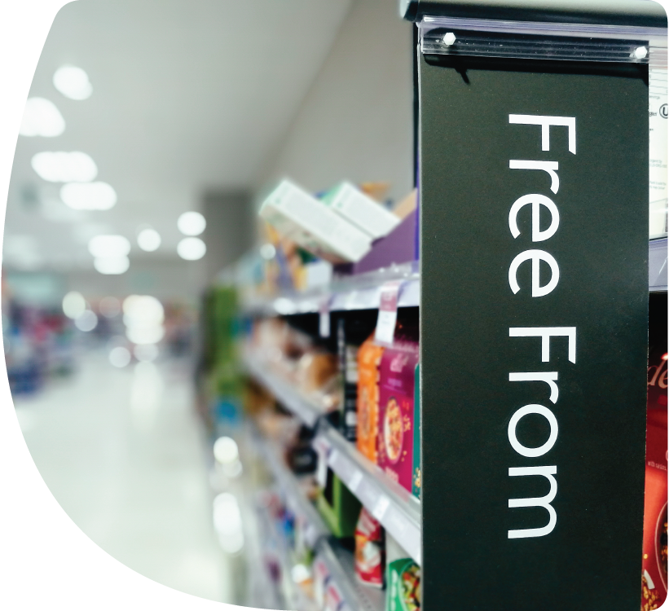
Nathaniel spends a significant proportion of his income on disability-related costs. To support his conditions, he can only eat certain foods and brands. He also needs to use a high amount of heating and hot water to get by.
Being disabled means that Nathaniel cannot cut his costs by simply reducing spending or usage of these essentials. For him, branded products and high energy usage are not luxuries but essential expenditure.
“I can't just choose cheaper food or cheaper brands - I have to eat what I've got to eat. Because of my [conditions]…If [the food I need] goes up in price, there's nothing I can do about it…so, that's been a big impact.”
“The fuel prices and energy prices - again, I need to use more hot water [for washing myself, clothes and personal care for my condition ]...So whatever the energy price is, I've got to pay it; there are no ifs, buts or maybes in that. It's just got to happen.”
Effective management of Nathaniel’s impairments requires significant spending beyond his prescription charges. This included paying for private health care. Nathaniel is now thousands of pounds in debt. But, he felt he had little choice to take on this financial burden to ensure an acceptable standard of living.

“I had [health issues] which were misdiagnosed consistently. So, my [condition deteriorated] completely...I had to wait for years to have surgery...And then that failed, and I had another surgery. Which again failed causing me to need a colostomy bag; the NHS waiting list would've been about 12 months to have that done.
I was basically incontinent and couldn't do anything, and spent every evening rolling around in pain...spending four, five hours a day on the toilet…So honestly, it was either pay for surgery or go to a bridge [to take my own life]. That was where I was at, and it sounds awful, but that was the choice I had… There was no other way out”.
Nathaniel is concerned about the level of benefits he gets to live on. Although he has a full-time job working from home, Nathaniel has significant debts due to disability-related costs. He is unable to cover his day to day extra costs from his disability benefit payments.
“So, I'm relying on my wages to pay for disability-related costs rather than my PIP. And you've got other people who are using PIP to pay their rent, when it should on disability costs. So, PIP is paying for, probably, half of my disability-related costs...the rest of it is being covered by my wage…I think [the PIP payment] is just not enough and the whole thing needs to be reformed, massively, from the assessment to the amount of money people get.”
Nathaniel is very concerned about the forthcoming review of his PIP benefit payment. He had to appeal his first application, so he mistrusts the system. Nathaniel lives with a feeling of dread about the process. He has no confidence in the fairness of the benefits system the next time round.
“PIP was a nightmare…I got declined the first time. Because everyone does. And then I got [my PIP award] after the mandatory appeal. I didn't have to go through tribunal, luckily. But I've got that up for renewal in a couple of months. So, I've sent off all the information and I expect to be declined and have to go through appeal again, so it's just a nightmare.”

The reality of dealing with extra costs
Paying for essentials and managing extra disability-related costs can be impossible with the limited budgets many disabled households have. Disabled people and their families frequently have no choice but to miss out in many areas of life.

Rationing or going without
This often means going without items and activities which are an important contribution to the health and mental wellbeing of disabled people and their families. Their relationships, enjoyment of life and engagement in society are all affected by the constant financial management. Going without these vital items and activities leaves many people feeling isolated and desperate.
"[My financial situation] is really affecting me, and it's made me feel suicidal at times, it really, really has. Because it's, like, I'm going under here, and no one is going to save me. Because I've got no family, I've got no partner, I've got no job. No one is going to save me from this, you know? I am literally going under and there's nothing I can do about it really, because I just cannot afford to live in this country as a disabled person, you know? I can't and that makes me feel like I don't want to-, I can't go on. It really does make me feel that I can't go on for much longer."
Charlie, 50s, South East England
For many, disability benefits are simply not sufficient. They often do not cover essential living and disability-related extra costs. This lack of financial support leaves many households with feelings of financial fear.
“[My PIP benefit] is not cutting it for me…There's a very big shortfall…so there are so many things that you give up. And you think, 'I can't give up anymore.' And still, you're at that point where you know that you're teetering on the edge, at the end of the month you're like, 'I've got £1’.”
Emma, 50s, East of England

"[Being on benefits] doesn't give you that financial security when it comes to planning for the future. [This level of support] doesn't begin to provide the financial security that would be good if you're disabled, and you do end up out of work for a long time, or you're never able to work.”
Dee, 20s, Scotland
Where possible, disabled people and their families are cutting back or going without items or activities in the following areas of life:
Utilities – reducing or stopping use of heating, electricity, hot water, kitchen appliances.
Food – missing meals, switching to cheaper food, reducing spending on groceries, using food banks.
Medication and health maintenance – cutting back on prescriptions, over the counter medicines, dental appointments, the cost of taxis to see GPs or health professionals about new concerns.
Alternative treatments and therapies – cutting back on sports or deep tissue massages, injections, supplements, experimental therapies and treatments, or private counselling.
Condition-specific support equipment – affordability of new wheelchairs, mobility scooters, batteries for electric mobility aids.
Everyday care and family items – reducing spending on items such as suncream, new children’s shoes for school.
Holiday and days out – holidays, family outings and leisure time.

Physical and mental health, wellbeing and quality of life
For some disabled people, this constant financial pressure and going without impacts the effective management of their condition, health, mental wellbeing and quality of life.
"It has an impact on the mental health because, you know, I want to do things. [I would like to] see Portugal, go and see Spain… [Holidaying there is] not ‘expensive’ [for non-disabled people], but for me, it is. Because I've got to organise a wheelchair and I've got to try and pay for extra for my scooter. It's extra money…but that's not going to happen because of my disability now, so. I don't like to think about that because it makes me very depressed. It puts me in a very low place…Just the thought of being here for the rest of my life in this room just makes me feel very not too happy. These things I don't normally think about but every now and then, it hits you. And then you feel almost worthless or a burden.”
Patrice, 60s, East of England
Many disabled people and members of their household cannot afford to spend money on leisure, hobbies, or activities that make life enjoyable.
“I think hobbies and leisure are absolutely essential costs because they help you retain the true essence of your being and who you are.”
Hanna, 40s, Wales
Many disabled people tell us that their quality of life is poor. They feel they are ‘just existing’ by surviving each day. Trying to pay the bills while managing their condition and the associated extra costs.
“Disabled joy is something that is not really a focus of policy-makers minds and everyone else's minds for that matter, including disabled people, as how as a community we can be happy in these challenging times.”
Dee, 20s, Scotland
Cutting back is not just undesirable, it also has a significant impact on disabled people’s physical health.
“I'm freezing cold in winter. When I get too cold, it can trigger an adrenal crisis, which is a life-threatening situation where I have to inject steroids. I had to do that twice last winter [because I couldn’t afford to heat the house].”
Charlie, 50s, South East England
“The hospital is a bit far [for my mobility scooter], so you've got to pay out for taxis. And the blood tests are every three months, and then if I find that there's a pain somewhere else, the doctors want me to get another test. So, I just don't go to the doctor.”
Patrice, 60s, East of England
Constantly needing to cut costs in this way has long-term negative impacts on the emotional wellbeing of disabled people too.
"[Last winter my bills were] £400 [per month], just gas and electricity. So during wintertime, my whole social life completely stopped."
Ayesha, 40s, South East England
Feelings of guilt are common when household funds are diverted to cover disability-related costs. Many disabled people report feeling responsible for depriving partners or children of money and opportunities.
“I think any of the disability costs, I feel a lot of guilt spending it, even though it's not really my fault, [...] because a lot of money is spent on my health – and the same isn't spent on my wife.”
Ella, 40s, East Midlands

The anxiety extends to how disabled people and their families will cope in the future. Worsening physical or mental health was a particular worry. People worry about juggling essential day to day costs, while trying to prepare for potential disability-related extra costs in the future.
“[My disability-related extra costs] have definitely put me in a lot of 'financial disability'. That’s a good way of putting it, because it's that worry and anxiety about it…when you've got disabilities which are progressing and getting worse. You know, at some point, you're not going to be able to work, probably…It makes you feel, sort of, I don't know, hopeless, helpless.”
Nathaniel, 30s, North West England
“We're really low on [savings] right now. If my wheelchair were to go now, I couldn't replace it again at that cost.”
Jo, 40s, Yorkshire and the Humber

Charlie’s experience 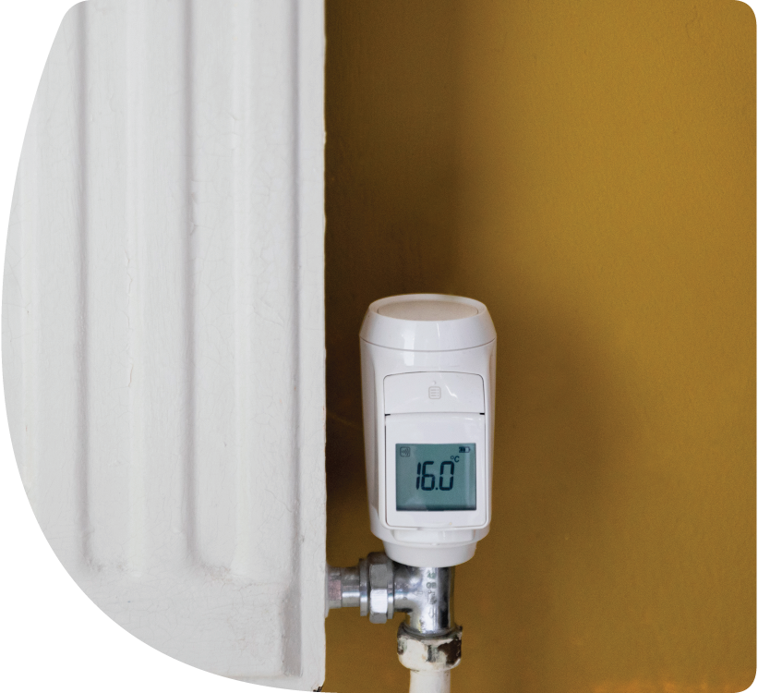
Charlie has various conditions that require different diets, or she becomes extremely unwell. She also uses hot water and heating to manage conditions and pain. When Charlie is unable to afford to manage her impairments effectively, she goes through a cycle of different illnesses.
Charlie has cut down on heating, electricity and water to save money, which has been detrimental to her physical health.
“I can't afford to leave [the lights] on, so I have to turn those off and then that means that I've had a couple of falls, because I can't see.”
These cutbacks in essentials have led to a difficult living situation for Charlie, with nothing left to economise on.
“I haven't got anywhere else to cut it from. There is nothing left really to cut.”
Charlie’s living standards are much lower than anyone would deem acceptable. This contributes to her very poor mental health and low sense of wellbeing. She is desperate with worry, constantly feeling helpless in trying to survive day to day.
“I can't sleep and I'm constantly worried about how I'm going to make ends meet the next day or the next week and the next month, you know? And just this absolute feeling of helplessness.”
“The stress is killing me, it really is. It's absolutely wrecking my mental health and it just seems to just get worse.”
Insufficient financial support means Charlie is missing out. She is sacrificing her standard of living, with no space to enjoy life outside of managing health conditions.
“The full-time job is looking after my health and it's bad enough, and that kills your quality of life…just all the horrible things I have to deal with for my health, and all the hospital appointments and everything. But in between that, to just to get some quality of life, some stuff that would be actually nice to do…that I really need; things that you want and things that you need would be great.”
With more financial support for the essentials of living, Charlie believes her quality of life would significantly improve.
“I'd be able to go on a holiday, I'd be able to buy a wheelchair, I'd be able to pay for my medicine, I would be able to go to the cinema and I'd be able to eat without going to a food bank. It would change my life.”

Jack’s experience 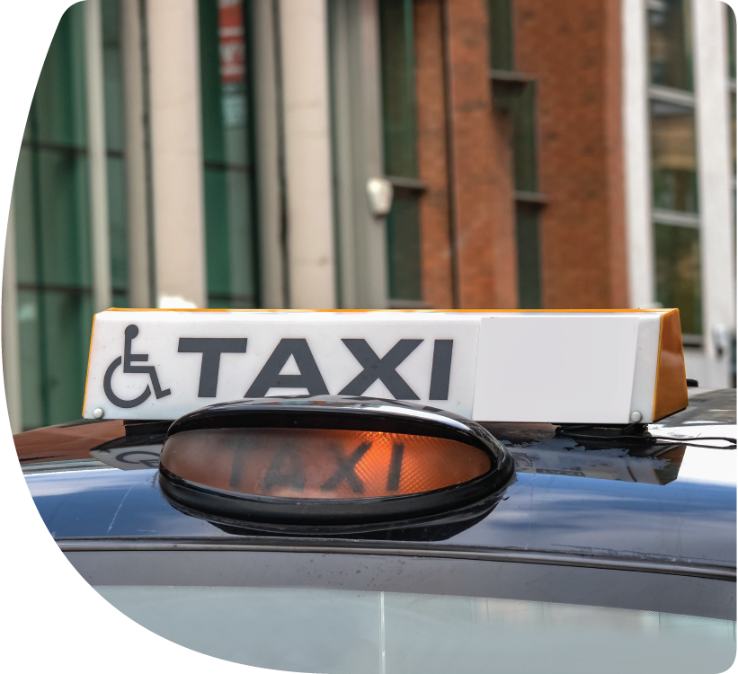
Jack is “heavily reliant” on taxis since becoming visually impaired several years ago. He feels that public transport is not safe for him to use.
"I find the bus routes and the buses are just really quite inaccessible. And a lot of drivers aren't really aware - there have been many incidents where a driver pulls away before you even get a chance to sit down. So, I think that just causes me a lot of anxiety, which then pushes me towards using taxis because they're a lot safer…That's probably the major [extra cost] for me.”
Jack can spend an average of £16.75 per week on taxi fares. This equates to potential extra costs of almost £900 annually, for local travel alone.
For Jack, paying for taxis journeys was not discretionary spending, as they might be for non-disabled people. Taxis use is essential and “of very high importance” to Jack. He says that the regular use of taxis is “not really a luxury for me, it's a necessity”.
Jack also incurs considerable disability-related extra costs. Either to safely negotiate an event and travel further away from home. This often makes days out and holidays financially inaccessible to him.
“One thing I backed out of a while ago was going on holiday. It was just going to be a little weekend trip for myself, but then I realised that, going to an area I hadn't been to before, I would need the help, and then, obviously, the cost of having [a personal assistant] for the whole weekend would've been crazy amounts of money. That would've been about £600 for 48 hours. That's an extra cost, just for a weekend away, just to have someone with us.”
Jack often goes without and sacrifices fun and relaxation, from occasional hobbies to weekends away. This is because he cannot afford the necessary extra costs of a personal assistant to support him.
"Not being able to go out and do things in my spare time is sometimes dictated by maybe not the cost of the activity, but the cost of the help and support [I need to get there and when I arrive].”
Funding his everyday life is a significant issue for Jack. In addition to his part-time job, he relies on grants and charity donations to enable him to live comfortably and safely.
“I think I was quite lucky in the respect that the charity nearby that I deal with, that supports people in my area with their visual impairment, [provided me with] a lot of stuff, free off them, that I needed. Like, day-to-day, around the house…Lightbulbs but, like, the brighter ones because, obviously, brighter lights help, a lamp, various kitchen equipment – like a specialist non-slip mat, for when you're cutting veg, so it doesn’t move, and BumpDots to put around the cooker, and [other places] where you turn the knobs and stuff. I also got a grant from the RNIB, for a video magnifier, so they cost about £500 to £600."
And when constantly financially stretched, the emotional impact of the “dreaded PIP assessment” and the review process is clear. For Jack, the stress and anxiety arose not only from the demeaning and invalidating procedure of the assessment itself. But also the fear of how to financially survive in the future. He worries particularly about the risk of his benefit support being removed.
“If I was told I wasn't entitled any more, how would I get about? If I don't have PIP coming in, who pays for the taxi? If you've got to take nine months to get to appeal, or something like that, then do I go nine months without leaving the house?”

Disabled people and poverty
To understand the impact of extra costs, we need to consider them in the context of poverty rates.
Disability and poverty are linked with nearly six in ten (58%) of all people in poverty being disabled themselves, or living in a family that includes a disabled person.
There is now a wealth of evidence demonstrating widespread financial insecurity, poverty and deprivation among disabled people due to the cost of essentials:

Food poverty
Among people in poverty, disabled households are almost twice as likely to run out of food (12.3%). This is compared to 6.7% of non-disabled households.

Scope’s Winter Concerns survey found that over 1 in 7 (15%) disabled people aged 18-54 had used a food bank to help manage their living costs. 34% of all disabled people surveyed said they were buying lower quality food, skipping meals or eating less. This is almost twice the number non-disabled adults (18%).

Energy poverty
There are 2.1 million disabled households in the UK, experiencing stress in affording fuel this winter. This represents 1 in 7 disabled households (15%). Age UK estimate that if an energy social tariff had been in place, two thirds of these households (66%) would not have faced fuel stress this winter.

Transport poverty
The Social Market Foundation estimate that transport costs contribute significantly to poverty. This pushes over 5 million people, or 8% of the population, into poverty. They calculate that every 10% increase in the relative speed of public transport compared to driving, saves the average household over £434 per year.
The lack of accessible public transport particularly disadvantages disabled people. This makes them rely more on private transport (motoring). Disabled people pay extra costs associated with adapted cars and running costs. As well as increased use of transport essentials like taxis.

Poverty in work
Disabled people and their families are more likely to face poverty. This is partly because their higher household living costs compared to non-disabled households.
Income poverty rates are significantly higher for the disabled population, but also among disability benefits recipients when compared to the wider UK working age population. Among those disabled people in work who also receive disability benefits, 12% are in poverty (when including their disability benefits within their overall income).


Recommendations
The burden extra costs places on disabled people and their families have been overlooked for too long.
Now is the time for all political parties to commit to end the price tag of disability. And address the inequality in disabled people’s standard of living created by extra costs.
This latest research sets out an important first step towards this. Focusing at the most basic level, of spending on essentials.
Disabled people face an extra burden of essentials whether they receive benefits or not. For those receiving benefits we know this is insufficient to cover extra costs and the extra burden of essentials.
Addressing the extra costs on essentials experienced by disabled households could tackled through a range of approaches. It is clear that focusing on support through the welfare system alone won’t be wholly effective in ending the disability price tag.
Scope’s recommended actions for the next Government are:
1. Reduce the extra burden of essentials by £12 per week for disabled households.
Based on the research, Scope makes three proposals for the focus of this support:
a) Direct this support at disabled people currently receiving PIP or DLA benefit payments
This approach would focus an essentials payment to disabled people who are PIP or DLA benefit claimants. A £12 per week addition to PIP and DLA would mean a total increase in benefit payments of £1.7bn a year for disabled people currently receiving these benefits.
This would reduce poverty amongst this group of disabled people and their family members by 115,000, and deep poverty would fall by 80,000.
Increasing these disability payments by £20 per week would see poverty fall by 205,000 and deep poverty 105,000.
b) Target the support at disabled people in the lowest income households
A focused approach of reducing the extra burden of essentials by £12 per week for all disabled households with the lowest 40% of household incomes (unequivalised) would mean a total reduction in costs of £2.5bn a year for these households.
This would reduce poverty amongst disabled people and their family members by 180,000 and deep poverty by 175,000.
Reducing the burden by £20 per week would see poverty fall by around 310,000, and deep poverty would fall by 300,000.
c) Extend support for essentials to all disabled people
All disabled households are affected by the extra burden of essentials. By reducing the burden by £12 per week for all households that include a disabled person, this would mean a total reduction in costs of £4.5bn a year for these households.
This would also reduce poverty amongst disabled people and all those people living in a family that includes a disabled person by 285,000. It would reduce those in deep poverty by 205,000.
Reducing the burden by £20 per week would see poverty fall by 510,000 and deep poverty by 335,000.
2. Introduce a government-funded discounted energy bill for disabled households
Scope has long called for a discounted energy bill for disabled people in receipt of disability benefits, and for those in receipt of means-tested benefits, carers allowance, or living below the poverty line.
We have called for a discount of 50% should be applied to the unit costs for this group of disabled people, funded through taxation.
This discount should also be linked to a new scheme to improve the energy performance of homes. This includes providing finance and support to fast-track retrofitting homes and utilising smart technology. WPI Economics calculate that upgrading properties to an Energy Performance Certificate (EPC) rating of C or better could mean cost savings of £567 per year to the occupiers of these properties.

Scope (2023) Disability Price Tag: The extra cost of disability
WPI Economics (2024) Disabled people’s extra burden of essentials
Social Metric Commission (2023) Measuring Poverty: Social Metric Commission Report 2023
WPI Economics consultants undertook quantitative analysis on the actual spending across households using the LCFS pooled data. They estimated the differences in day-to-day spending patterns for people with similar levels of income. Their regression model analysis accounted for socioeconomic and demographic characteristics of the households. Disability status was considered when there was at least one disabled adult in the household. This is together with whether a member of the household was claiming disability benefits (Personal Independence Payment or Disability Living Allowance) or other means-tested benefits with a disability component. The costings and poverty calculations were estimated using the combined dataset of LFCS and FRS.
Scope conducted the ‘Living with the Extra Cost of Disability’ study in 2023. A diverse range of individuals from Scope’s Research Panel representing 31 disabled households completed a weekly homework diary, over three weeks. The diary collated weekly household costs of goods and services. These were both disability- and non-disability related. 30 semi-structured interviews were conducted online with disabled people and their families. People spoke about managing household budgets and the impact of the extra cost of disability. This qualitative research will be published in March 2024.
WPI analysed the ONS Living Costs and Food Survey, pooling data from 3 financial years, from 2017/2018 to 2019/2020. Using different households’ income groups, they linked these datasets to the ONS Family Resources Survey 2019 and 2020 data sources. This created a combined dataset which they used for the research analysis.
There is no systematic UK-based national essential spending classification, WPI Economics used a recognised classification of essential expenditure created by the Australian Bureau of Statistics (ABS). This classification looks at relatively granular level of essential and discretionary household spending. Using the ABS classification, WPI Economics identified which items are essentials and discretionary within the main UK national categories of the individual consumption according to purpose (COICOP).
Although extensive, the budgetary data collected in the Living Costs and Food Survey mostly focuses on generic categories and spending of the wider population, rather than those for specific groups of individuals. For the disabled population, a number of the specific health and disability-related products and services are not captured fully, with spending in such areas under-estimated.
To compare these spending patterns, WPI Economics used regression analysis to explain the difference in the proportional spending on essentials between households. The various socioeconomic and demographic characteristics were accounted for in the analysis. Gender, ethnicity, housing tenure, region of residence, disability status taken together with the types of benefits received, whether means (UC, ESA) and non-means tested disability benefits such as PIP, DLA or AA) and household income (quintiles), after deducting housing costs.
WPI Economics carried out descriptive analysis to understand how much households spent on different items of their 'basket of goods and services'. As well as total spending devoted to essentials items for living. Their analysis estimated how much more disabled households proportionally spend on essentials compared to non-disabled households.
Assuming that disabled households maintain the same spending patterns throughout the period.
Scope (2023) Disability Price Tag: The extra cost of disability
Social Metric Commission (2023) Measuring Poverty: Social Metric Commission Report 2023
Scope own calculations using the latest wave (13) of the Understanding Society covering period 2022. University of Essex, Institute for Social and Economic Research. (2023). Understanding Society: Waves 1-13, 2009-2022 and Harmonised BHPS: Waves 1-18, 1991-2009. [data collection]. 18th Edition. UK Data Service. SN: 6614, http://doi.org/10.5255/UKDA-SN-6614-19.
Scope 2023 Winter Concerns survey. This explored experiences and concerns of 1017disabled households. Particularly in managing the 2023 winter.
Age UK (2024) Addressing fuel poverty of UK households in the winter of 2023/24
Social Market Foundation (2023) Getting the measure of transport poverty
Institute of Fiscal Studies (2022) Living standards of working-age disability benefits recipients in the UK
Ibid
Scope (2023) Disability Price Tag: The extra cost of disability

